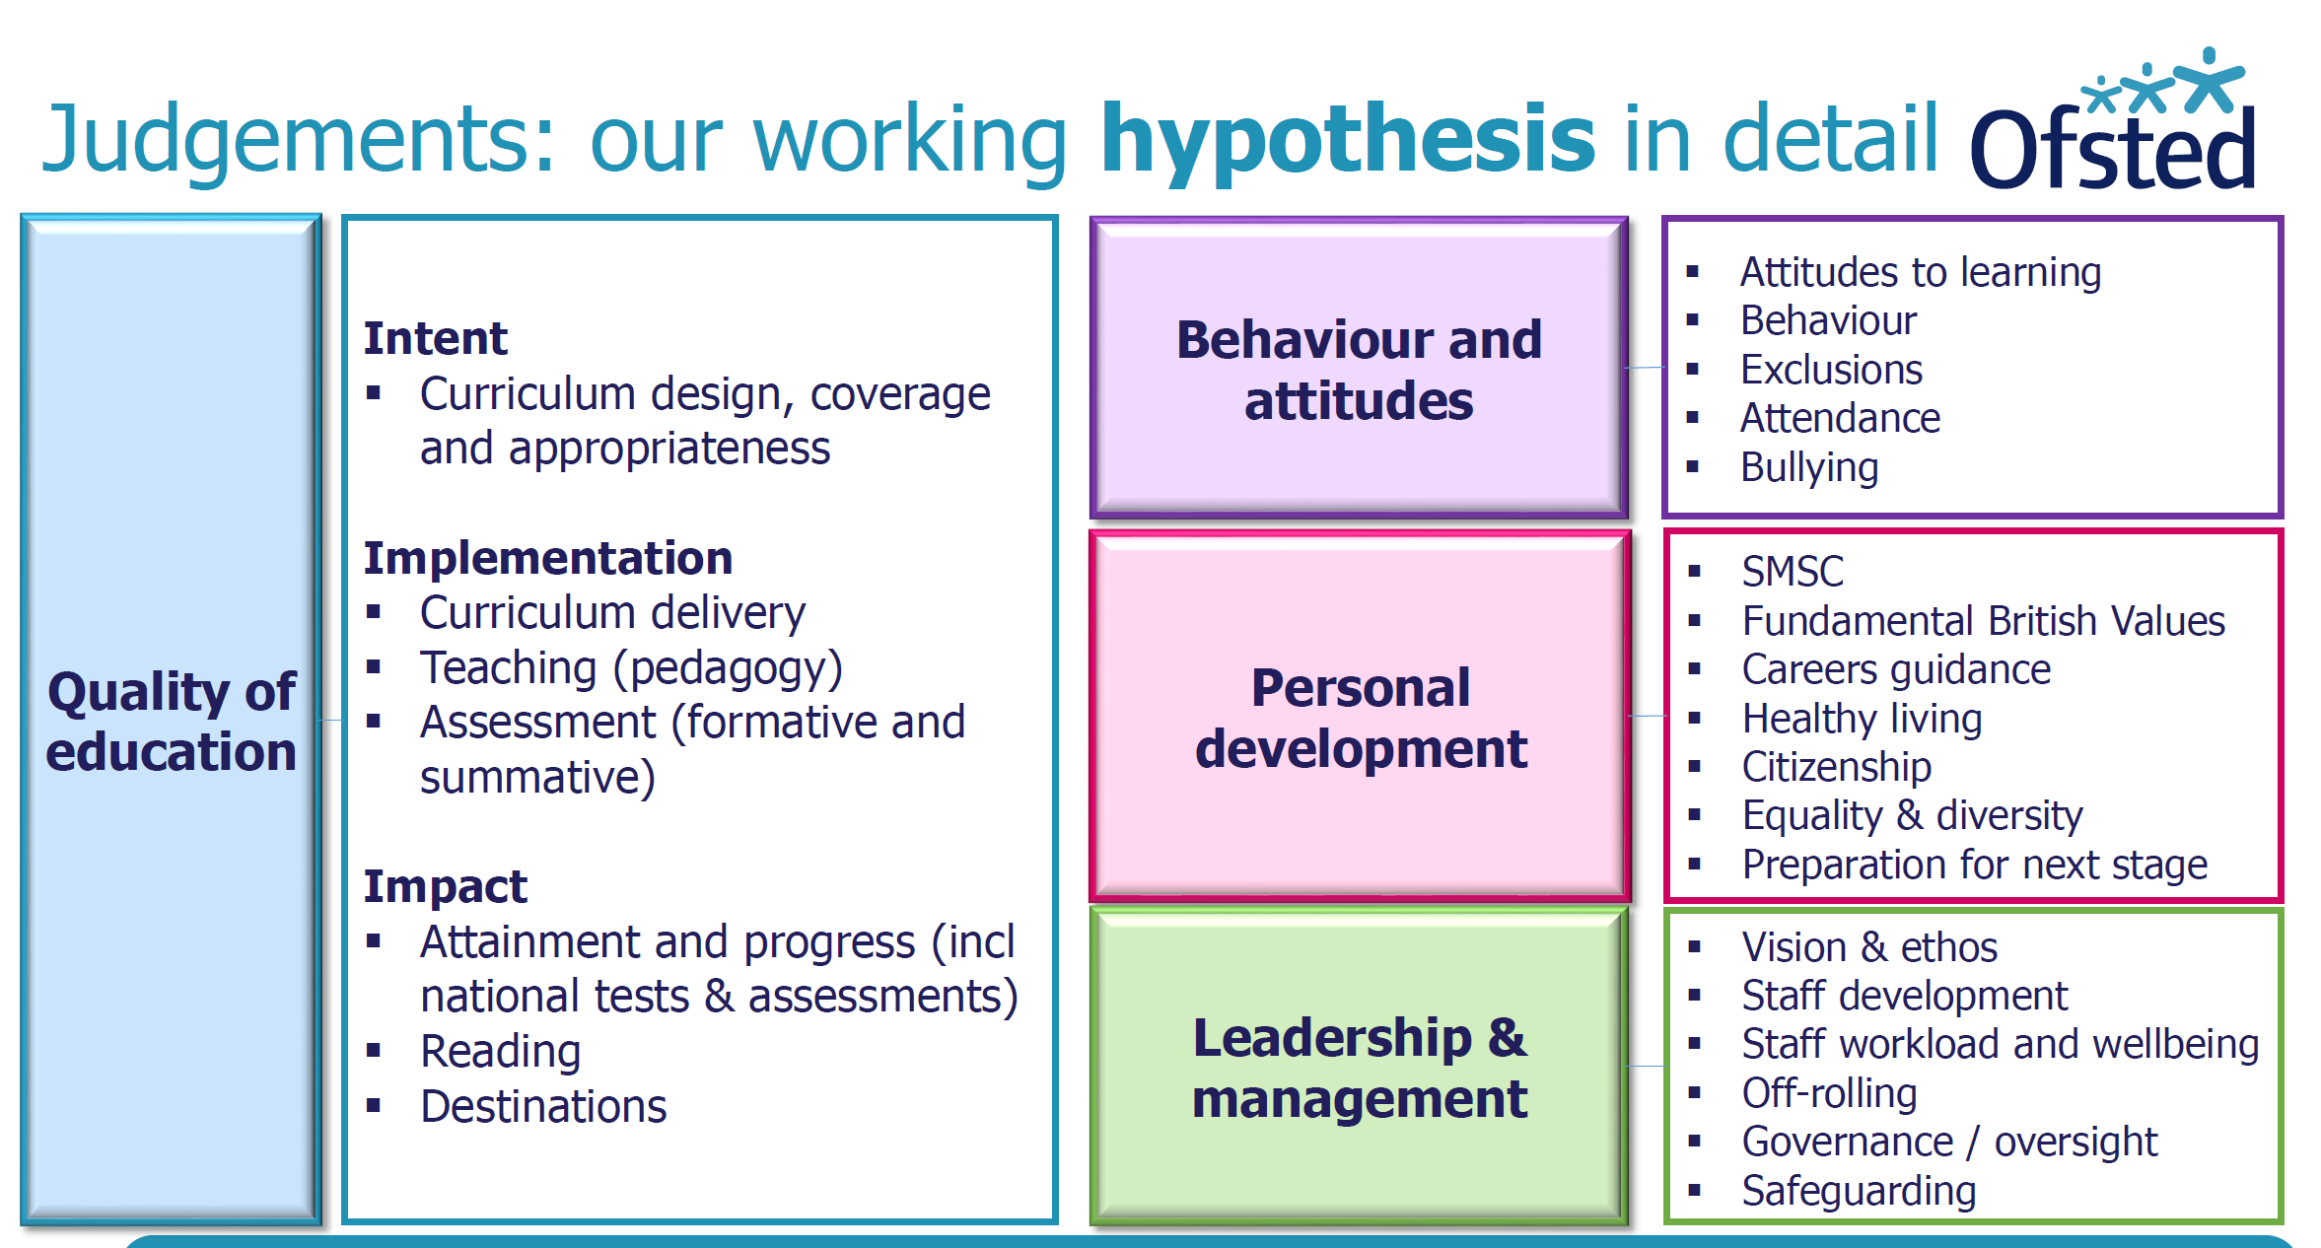
LGB Monitoring Form
Academic Year 2022 2023
Please email to your Clerk for the next meeting
Clerk1@romeromac.com or directorsclerk@romeromac.com

For monitoring Catholic Life, RE, Prayer and Liturgy (CW) Self evaluation doc for S48 Document here to aid thoughts

Name: | Date:
Focus of visit (link to Academy Improvement plan):
Summary of activities (this could be virtual on Teams)
(e.g. talking to staff and pupils, looking at specific resources, books or having lunch, lesson visits):
What have I learned as a result of my visit (relate back to focus of visit):
Aspects I would like clarified/questions I have:
Actions or key learning points for the Academy Committee to consider:
Any other comments/ideas for future visits:
Signed: ………………………………………………………..

