Ma Liang paints a horse and rides home to tell his friends of his adventure and the greed of the emperor.
The greedy emperor demanded he paint a field of gold but Ma Liang drew a storm and the emperor disappeared.
He met a wise man who gave him a magical brush.
He released a trapped fish.
There was a poor boy who painted amazing paintings with an old stick.
Number the events 1 – 5 in the order they happen in the story

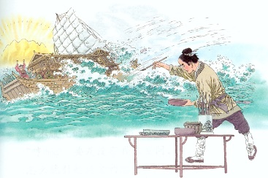

hhhh

