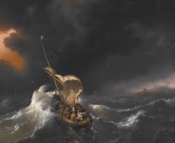  ‘Chang and the magic paintbrush’ | What do you notice? (retrieve)
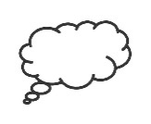  What do you wonder? (questions and predictions) | 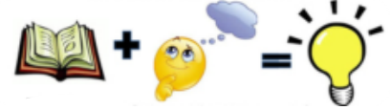What do you infer?

